Activity 4: Payment For Work
Financial Literacy Module: 15A Earning an Income
Career Education 8 :
- Change and Growth
- Connections to Community
- Life and Work
FL Outcome:
- Research different ways to earn an income.
Career Education Outcomes
- CG8.1 Analyze one’s self image including personal skills, interests, and behaviours and their influences on one’s life and work
- CC8.1 Examine how a disposition for lifelong learning connects to potential career pathways.
- CC8.2 Determine the contributions that work and work alternatives such as volunteerism make to the community and examine their importance to society.
- LW 8.2 Formulate a list of life roles and examine possible changes over one’s lifespan

Overview | This activity spans two curricula. At the end of this activity students will be able to identify various sources of income, explain the advantages and challenges associated with each, and demonstrate and understanding of how they can put money to work for them. They will also gain an understanding of how what they do now, their interests, and skills play a role in the development of their career.
Required Prior Learning | Module 4: Information Security
Time Frame | Two - Three hours
Materials | Teacher Activity Guide  - Class Set of Money and Youth Textbooks, p. 43 to 58 or download the PDF titled “Money and Youth – Sources of Income”  - Worksheets:  - 100+1 Ways to Make Money  - Employability Skills
DO: | - Distribute textbooks or Photocopy enough Money and Youth booklets for each student. You could also display via the projector and read as a class, or everyone can access the text online.  - Photocopy enough worksheets for each student  - Discussion: Follow the teacher activity guide and direct discussion and learning as you follow the text.
Assessment: | Student Worksheets and Discussion

Procedure:
      - Discussion.
- Why do we need to earn money?
- Begin the lesson by asking the students to indicate if they have any source of income.
- Record a list of their responses.
- Are there any other ways you can think of to earn money right now?
- Once the list is complete see if the items can fit into one of the following categories:
  - Wages and Salary
  - Self-employment
  - Interest, Inheritance
  - How could you use your interests, skills, characteristics, or hobbies to earn money right now?
  - How might you be able to use your interests, skills, traits, or hobbies to earn money when you are an adult?

- Once this has been done, indicate to the students that each of these types of income have their advantages and demands.
- Inform the students that they are going to go through a jigsaw activity.
      - Arrange the class into four home groups and have the students number off with the 1st group starting with 1, the second group with 2, the third group with 3 and the last group with 4.
- Once they have numbered off, have the students re-group into their numbered groups. These will be the expert groups.
- Assign one of the following tasks to each group:
  - What are the benefits and concerns about working for others?
  - What are the benefits and concerns about being self-employed?
  - How do you have your money make you money – for example, investing, interest? What are the demands placed on you when you do this?
  - What should you do with additional revenue sources such as government transfers, inheritances, lottery winnings?
- Allow the groups time to complete their task and then have them reform into their home groups at which time they will report back to their members.
- Once this has been completed, refer them to pages 49 to 58 of Money and Youth. Read as a group and have them compare their answers to what is found in the book.
- Conclude discussion with the following questions for comprehension:
1. What are the different possible sources of income?
2. What are the different ways of looking at retirement?
3. What is the difference between (a) wage, (b) salary, and (c) benefits?
4. Why is Canada experiencing a skilled labour shortage?
5. What are the things most important to you as you consider your career and the kind of jobs you want? 6. How can the forces of demand and supply affect job opportunities and wages and salaries?
7. What is “LMI”? How can this be helpful to you when considering an occupation?
8. What are some of the factors that affect your job prospects?
9. What are some of the “benefits” you might be able to receive from an employer?
10. Why is it becoming more challenging for Canadians to be able to save for retirement?
11. What kinds of income can be made from investments?

      - Complete the worksheets “100 + 1 Ways to Make Money” and “Employability Skills.”
      - Present this question:
        - What is your favourite thing to do? Now, figure out how to get paid for it.
        - What does this mean to you?
        - Did the previous activity help you figure out what some possible things you could pursue in the future?
      - Conclude the Activity. The next activity that we are going to look at is how to research and plan for a possible career choice. We will use what we learned today to help

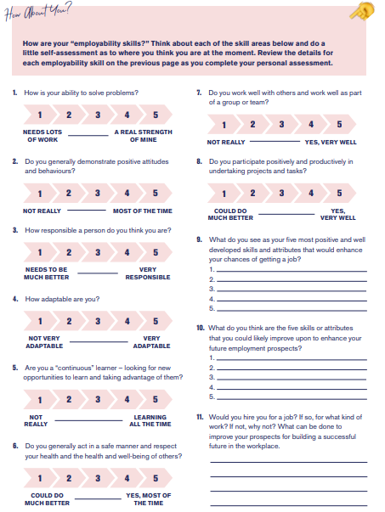
100 + 1 Ways to Make Money
There are many ways to earn a living. Some work for others, some start their own business, some may even sell or develop an idea that is innovating and cutting edge. Fill out the following chart to get you started. There are examples to help you get started.
SKILLS, Hobbies, or Activities | Earning MONEY Now | Career Connection for the FUTURE
CHORES AND ODD JOBS
Yard Maintenance | Mow lawns, weed gardens, rototill | Landscape Architect  Landscaping business  Yard Maintenance Business
SKILLS AND ABILITIES
Good with Kids | Baby sitting, working with youth groups, | Teacher, coach, own and operate a Day Care
Drawing and Illustrating
INTERESTS AND HOBBIES
Wood working | Building Fences | Home Builder, Construction Worker, Furniture Maker
VOLUNTEERISM

